

Last Updated July 2026

A Peaceful Home in the Heart of Massachusetts
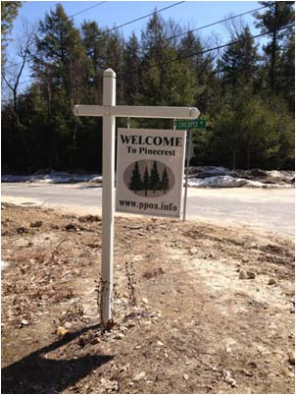
Our mission is to promote and foster recreation, relaxation, health and fellowship of the members, and to protect, maintain and improve the recreational land and open space in Pinecrest. The neighborhood offers many activities including hiking trails, a private beach area with a great playground, and lakes that are great for boating and fishing.
The Pinecrest community and PPOA Board of Directors would like to welcome you to the neighborhood. As a deed fee paying property owner in Pinecrest you have full access to private Cushman Pond. With a beautiful sand beach for swimming and access for boating and fishing, our pond is the focal point of the community. Above the beach there is a playground that includes swings and a basketball court. Also, as a paid member you have access to miles of groomed hiking trails which wind through Pinecrest owned common land. Our lodge, located at 84 Bemis Road, is the site of the PPOA Annual Meeting as well as monthly board meetings, which are held on the first Tuesday of every month. Meetings are open to members, and we encourage all to attend. The lodge, with its beautiful southern view, is available for member rental on a first come first serve basis, and is frequently used for parties, family gatherings, and small weddings. We hope this welcome package offers you a glimpse of what Pinecrest has to offer.

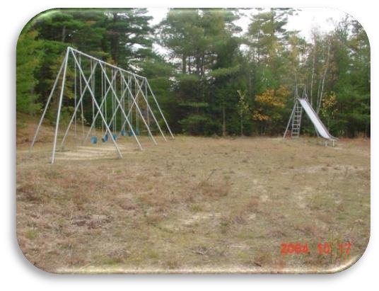
As a paid member, you have an opportunity to help protect and preserve our unique community. Please check our website, PPOA.info, on Facebook Pinecrest Neighbors of Hubbardston (private group), Pinecrest of Hubbardston (public group), and the entrance signs for upcoming parties, gatherings and clean ups. It’s a great opportunity to meet neighbors and have some fun.

WHY A PROPERTY OWNERS FEE?
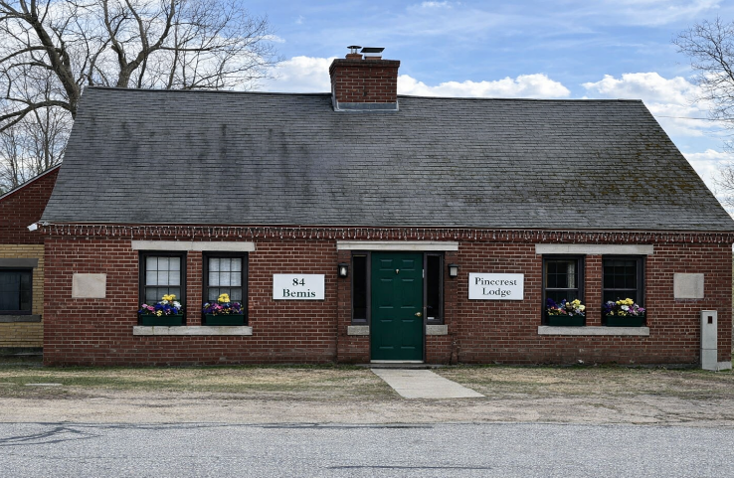
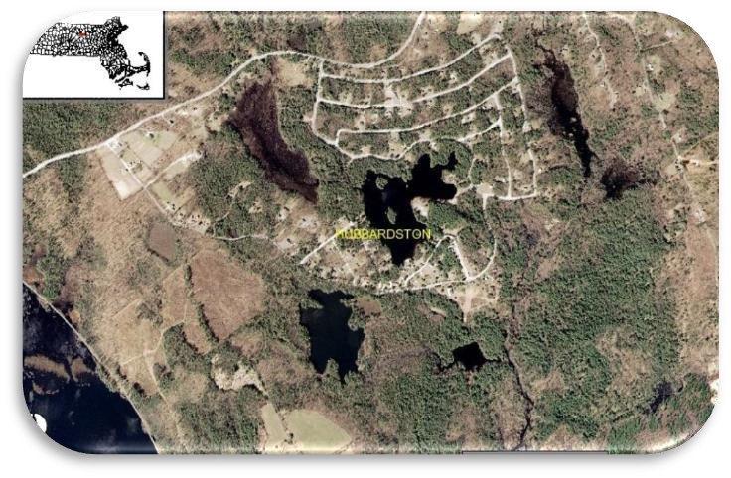
Pinecrest Property Owners are required to pay a membership fee annually. Payment of this fee gives owners voting rights at the annual Pinecrest Property Owners Meetings held the first Sunday in May as well as access to our facilities, due on April 1st of each year. This allows members use of the Cushman Pond beach, water access for boating (no gas powered motors, electric trolling motors are allowed), fishing, and rental of the Pinecrest Lodge. This fee is our primary source of income and is necessary for maintenance, improvements and upkeep for all of our facilities. The fee itself has the ability to fluctuate on a yearly basis based on the board’s recommendation and a vote by the association during the annual meeting. The fee is just $200 a year! It is seen as modest and reasonable considering the benefits it offers to our members, and it is absolutely vital to the preservation of Pinecrest assets.

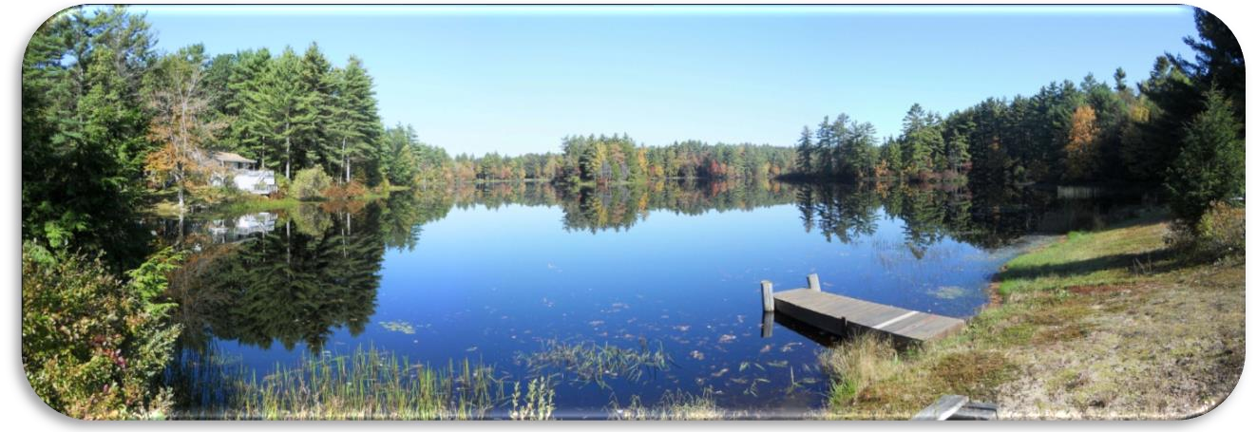
A panoramic view of Cushman Pond submitted by a neighbor just off of the pond

LODGE RENTALS
Lodge Rentals available to members in good standing; those who have paid the annual fee. The lodge offers the following amenities:
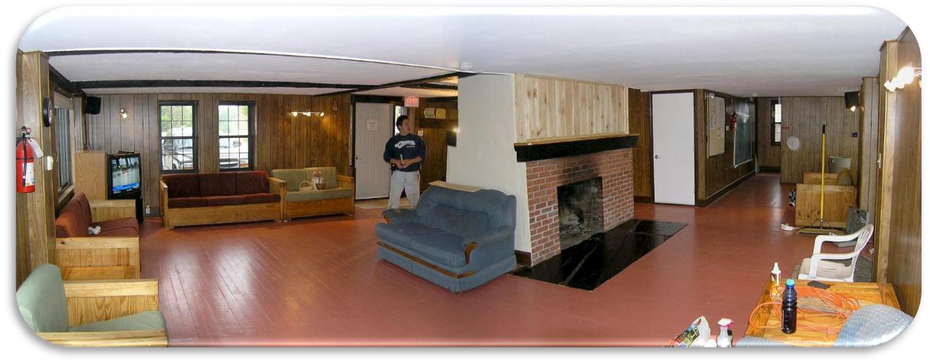
- Couches, chairs, end tables, non-working fireplace
- TV , stereo
- Kitchen with stove, refrigerator, coffeemaker, microwave, country table and chairs
- Large folding tables and chairs
- Restrooms
- Porch with overhang and two large picnic tables
- * Beautiful southern view!

Lodge Rental Fees:
$50 per day usage fee
$50 per day usage fee
$50 security fee (refundable if cleaned and undamaged)
Contact PPOA rental agent Bob Brooks
978-815-4122 for availability

